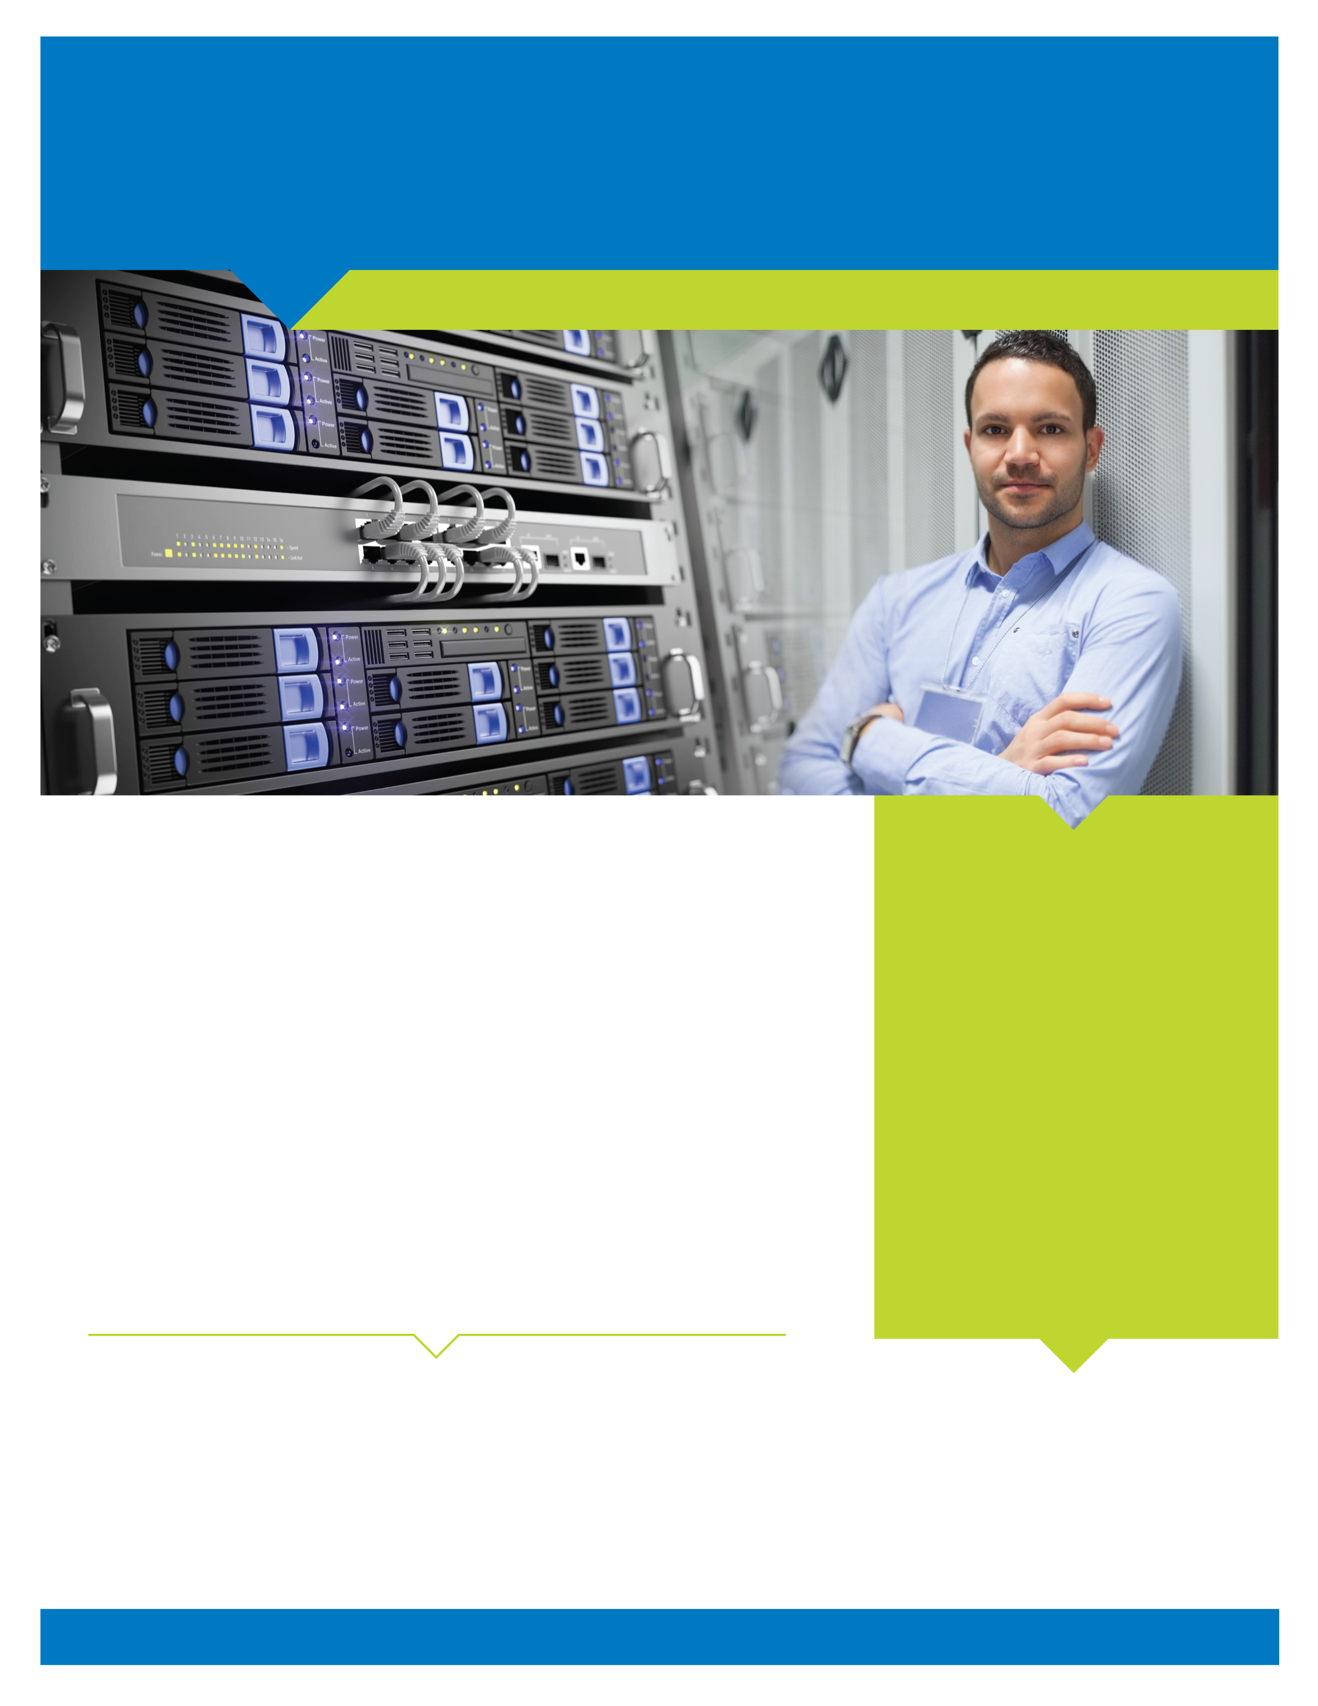
Hand Off Your Technology Hassles to Us
Money Well Spent?
- In 2012, the average annual IT budget for small and midsize businesses (SMBs) was up 15% from 2011.
- SMBs with one to 20 employees spend $1,900 per employee on technology, more than twice the $700 per employee organizations with more than 250 employees spent.
- The average SMB devotes 6.4% of its revenue to IT expenses, and 80% of that is spent after the initial technology purchase.
Managed IT Services
When someone asks what your company does, you wouldn’t say “managing information technology,” would you? If too much of your professional time and resources are spent outside your interest and expertise, and if IT issues distract you from growing your actual business, we have a suggestion.
Leave Your IT Troubles to Us, So You Can
Get Back to Doing What You Do Best
For an easily budgeted, small, fixed monthly fee — a mere fraction of the cost of hiring a technician — we’ll take away the worry, frustration and considerable cost of managing your IT environment. Our managed IT services solution keeps watch over your systems 24/7, and we step in the moment we discover anything amiss. In most instances, you won’t know there was ever an issue. This proactive approach to IT maintenance keeps small problems from becoming big ... and expensive! More >>>>

Let us help you put your IT
Budget to better use.

740 Driving Park Ave Suite A2, Rochester, NY 14613 • 585.697.0649 • www.ccplus-usa.com
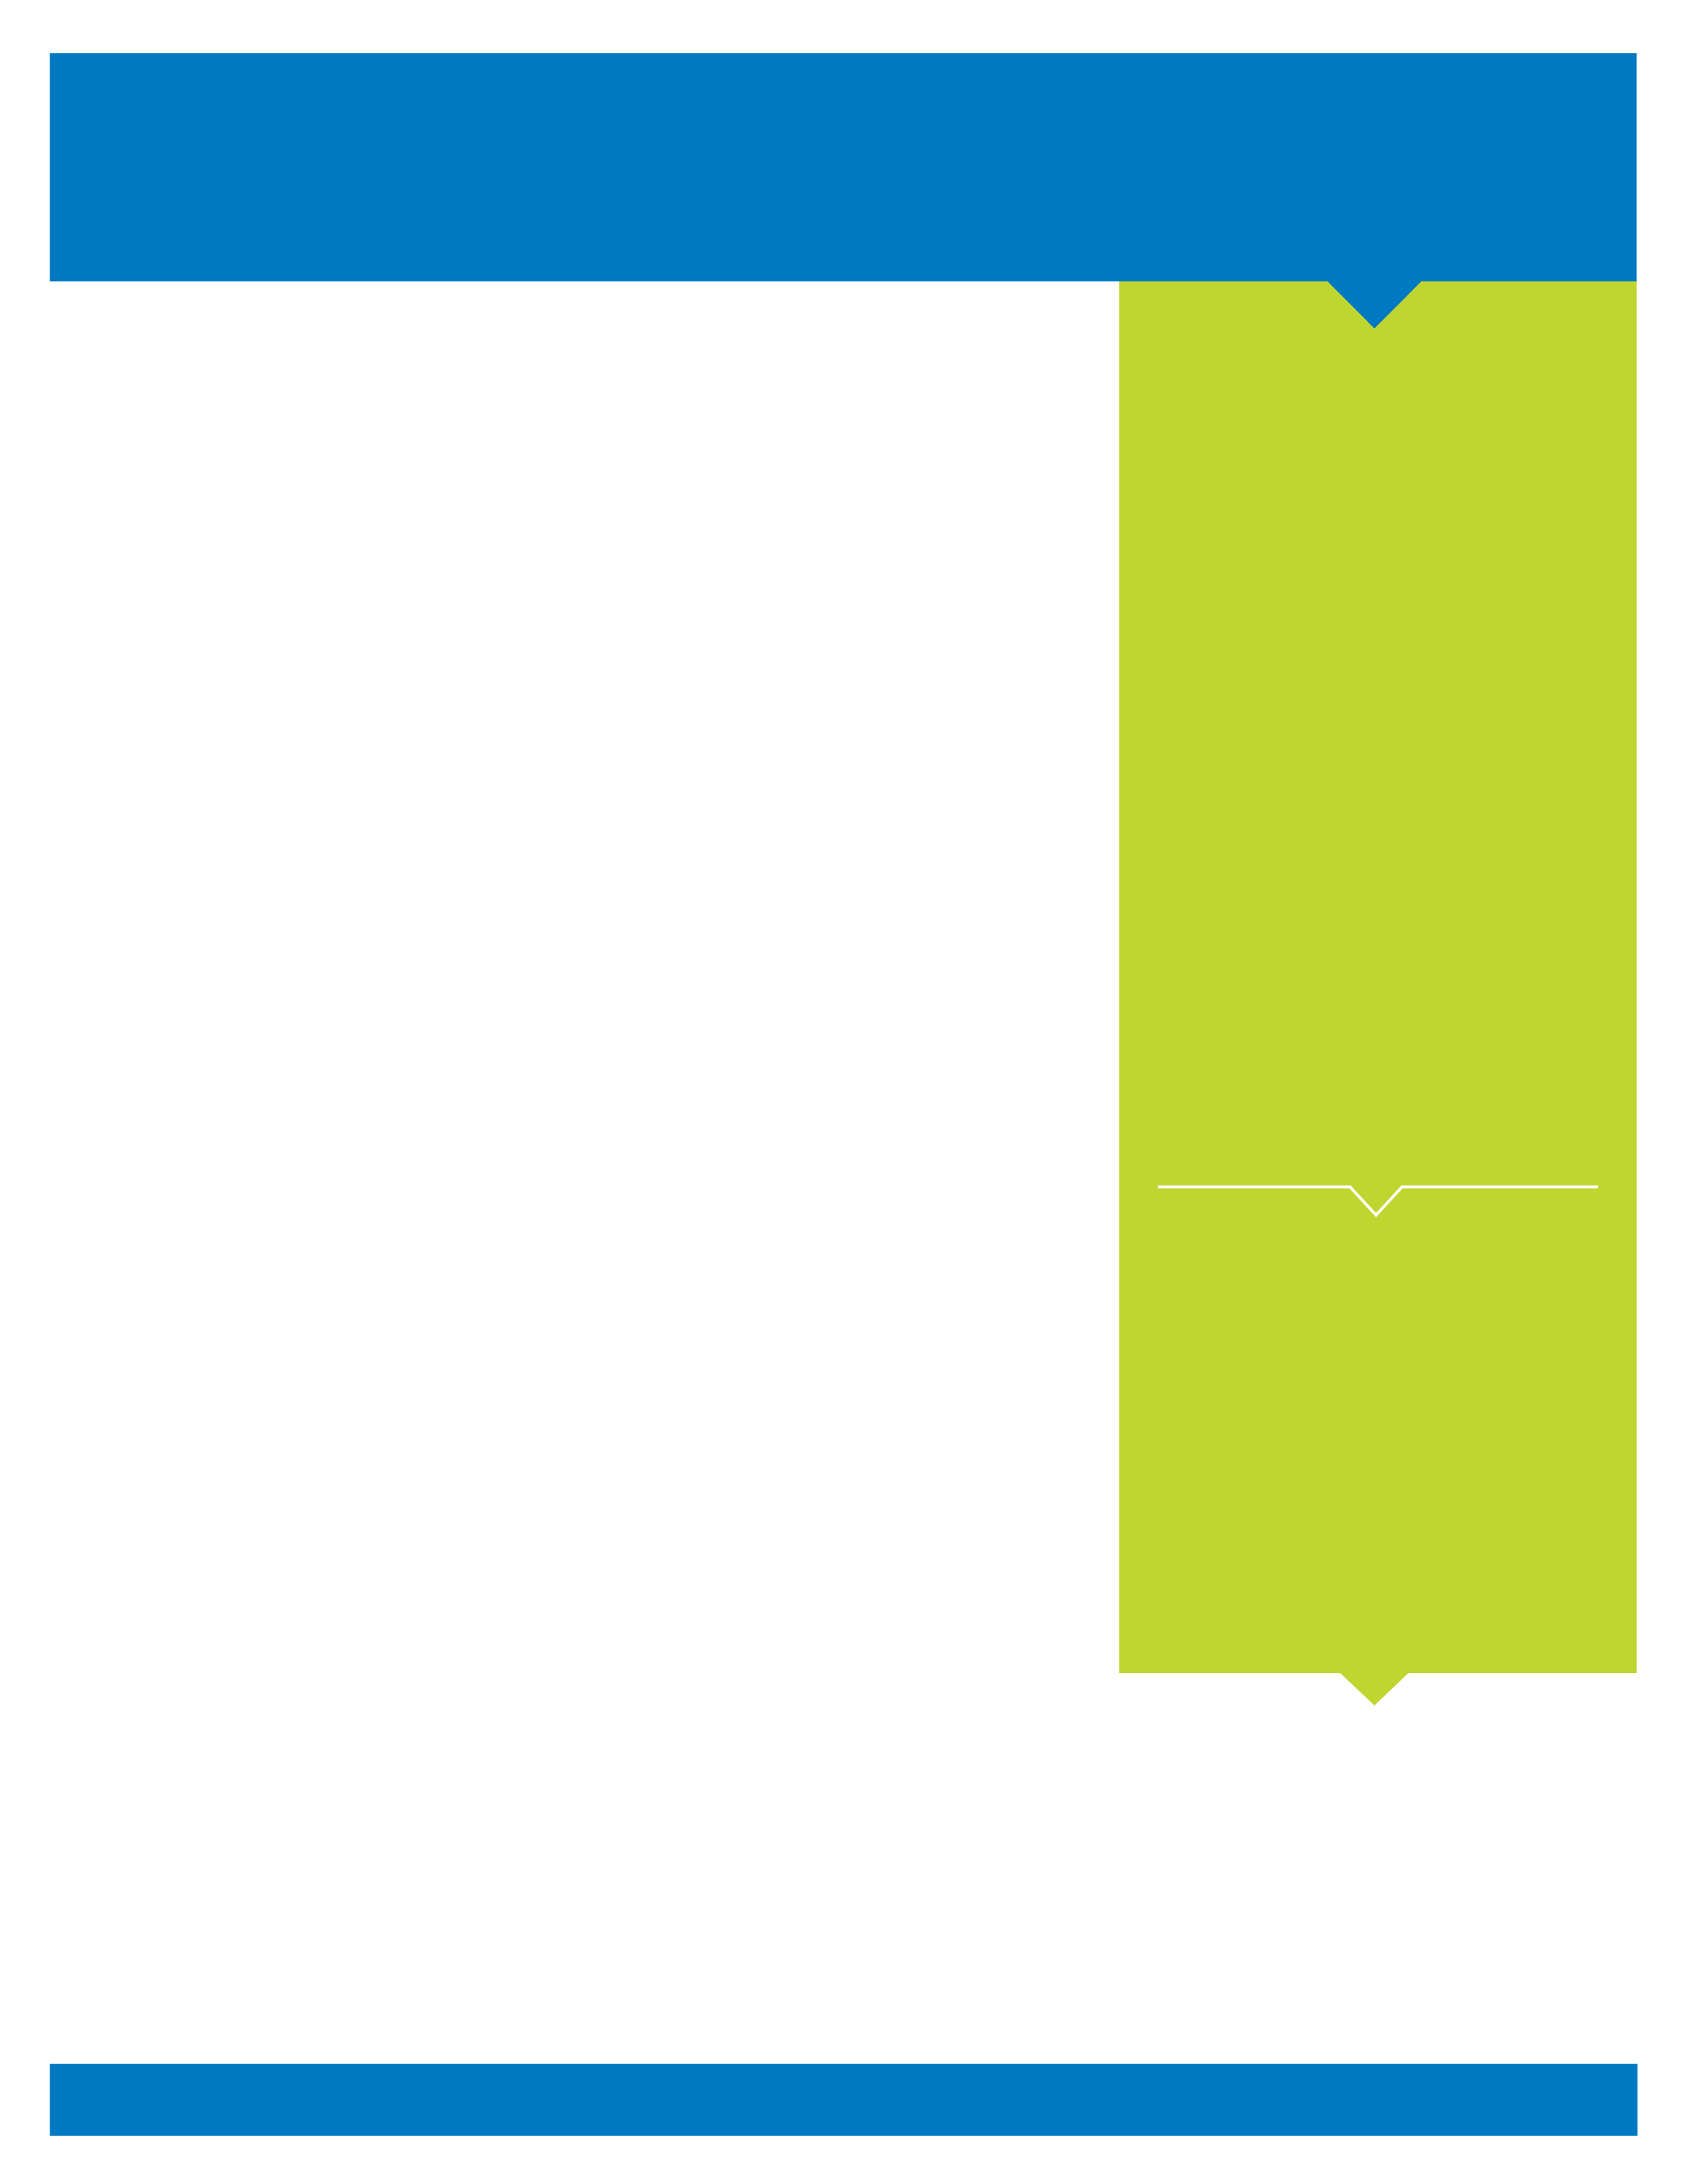
Presenting the Cost-Effective Alternative
to In-House IT Management
Our intelligent remote monitoring tools and 24/7 back-office services provide expert, cost-effective IT management to make sure your systems operate as required and deliver the ROI you expected. Key elements include:
Server Monitoring and Care
We utilize active-yet-unobtrusive software to track and analyze your server activity around the clock. When a system or function fails to work properly, an alert is generated and our team will immediately investigate the issue. Once we’ve identified the problem, we’ll take steps to fix it — remotely at first, and we’ll escalate our response
as necessary.
Desktop Monitoring and Care
Our preventive maintenance service for desktops proactively and regimentally monitors and addresses common problems experienced by desktop users. Whether it’s viruses, spyware issues or installing patches, we handle it all — quietly and in the background while your employees remain productive.
Mobile Device Management
With more companies looking for efficient, secure ways to incorporate their employees’ personally owned mobile devices into the workplace (also known as “BYOD — bring your own device”) we offer a response that answers all your needs. Our mobile device management (MDM) solution is the fastest, most comprehensive way to get devices configured for company access and to ensure that your organization’s data is secure on smartphones and tablets. As a fully integrated cloud platform, we simplify MDM with rapid deployment, as well as comprehensive visibility and control that spans across mobile devices, applications and documents.
Network and Security Assessments
How healthy is your overall network? On a regular basis, we’ll generate reports on the state of your systems, letting you know of any potential problems that fall outside safe parameters of our managed IT services. With these comprehensive assessments, you’ll always have the best information for choosing your most effective options.

What’s more, we continually build intelligence into our remote monitoring software by documenting the resolution to thousands of issues and incorporating them back into our software. And our expert technicians work around the clock to ensure your systems not only remain healthy, but also optimized for performance. Rest assured, our team is equipped to handle even the most complex and difficult problems.

Let us answer any questions you have about our managed IT services. We’ll show you the simplest and most affordable way to keep your IT network in top form.

740 Driving Park Ave Suite A2, Rochester, NY 14613 • 585.697.0649 • www.ccplus-usa.com

Rest Assured, We’ve Got
IT Covered
Through our managed IT services, we’ll:
- Maintain 24/7 watch over your entire IT environment (network servers, desktops, mobile devices, etc.)
- Identify and analyze server “events” for potential problems
- Remediate processes or services that fail
- Monitor servers and ensure security patches and anti-virus protocols are up to date
- Ensure that data backups are completed
- Install patches and implement service packs
- Manage and secure mobile devices (smartphones, tablets)
- Anti-virus solution and monitoring
- HIPAA and PCI Risk Analysis
- Remote and Onsite support options

Your Full-Service IT Provider

Our managed IT services cover
a full spectrum of technology solutions, including remote monitoring and management of your networks, 24/7 service desk support for users, and business continuity solutions to ensure your company is prepared for any possible disruption.

